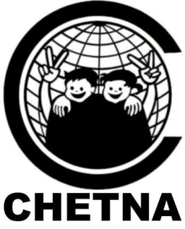

**Care for Contact Points**

Show you care for Street and Working Children

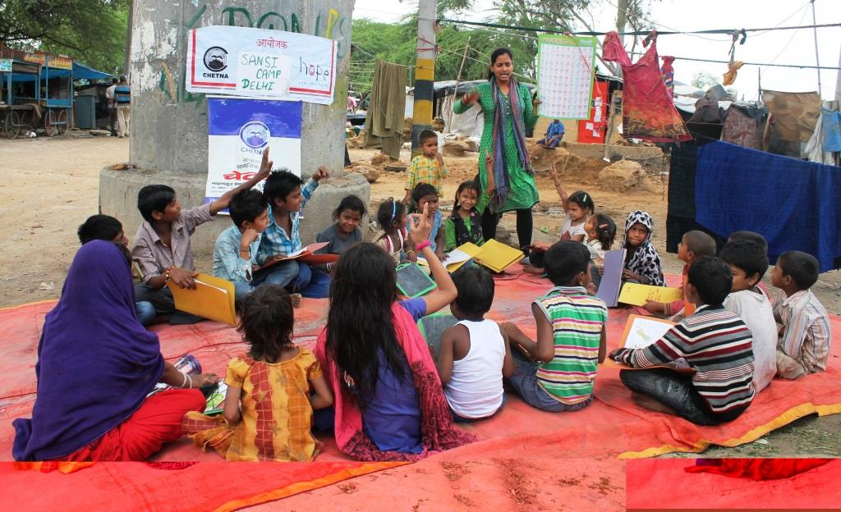

CHETNA Contact Points build trusting relationships with Street and Working Children and their families, with the ultimate aim to create a child caring society and system.

We empower the children through education – and provide a range of fun, creative ways for them to learn essential life and leadership skills. From visiting health care centres and police stations, to progressing to join Open Basic Education or a Formal School. The Contact Point is the start of their journey. We especially focus on girls, as the most vulnerable children.

Through the Contact Point the children also join Badhte Kadam, a unique Federation of Street and Working Children who advocate together for all Street and Working Children’s rights.

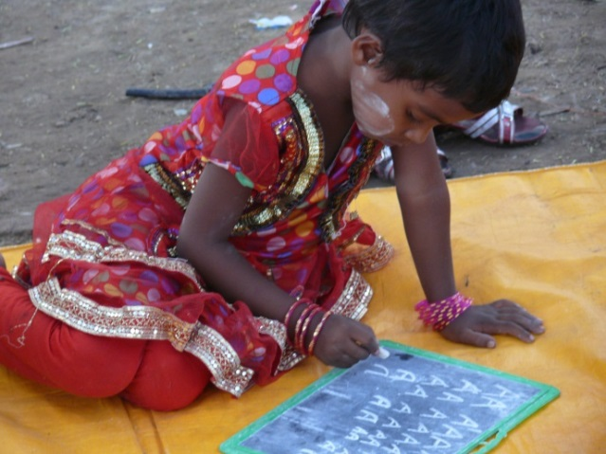

***“I am lucky and thanks CHETNA for approaching me and enrolling me in contact point. I always saw children going to school but never dreamt that I will be one amongst them one day”*** – Priya, aged 13.

**BUDGET:**

**Cost per month in INR to work with 30-50 children**

Cost of street educators and assistant project coordinator : 10,000

Cost of education and recreation materials : 3,500

Cost of monitoring and administration : 3,000

**Total cost : 16,500**

**Cost per year in INR: 198,000 (1980 pounds)**

**Optional extras to add value to the Contact Point**

Cost of Protection activities such as health and police visits : 5,000

Cost of educational trip for all children at the Contact Point : 5,000

Cost of two children attending residential leadership workshop : 13,000

Wow - that’s only 6,600 INR (66 pounds) per child per year to help them to turn their life around!

*(Please note these costs are based on 10 contact points running together in the same area) and each Contact Point runs for half a day, six days a week.

Why should **you**r **business** care for a Contact Point with CHETNA?

* You can assist the most vulnerable children in Indian society to access education and their child rights.
* We have a proven model of success so you know your donation is being spent wisely.
* Great value for money as we can reach out to 30+ children per contact point.
* You can come get involved and see your donation in action in your community.
* You can develop staff skills through volunteering on your contact point to improve communication skills, creativity and problem solving.